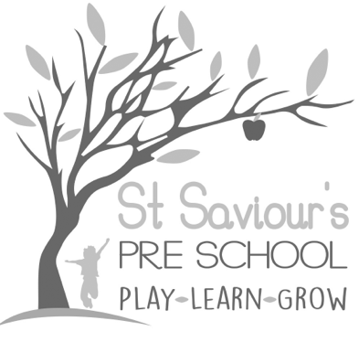
2.3 RETIREMENT

Written by: Claire Toms and Tina Alder Date: 1.09.22. – reviewed 28.8.25

Policy Statement
The purpose of this policy is to set out St Saviour’s Pre School and Nursery’s approach to the retirement of employees.

Retirement Age
- The setting does not operate a compulsory retirement age for its employees.
- The setting is committed to equal opportunities for all its employees.
- The setting recognises the contributions of a diverse workforce, including the skills and experience of older employees. It believes that employees should, wherever possible, be permitted to continue working for as long as they wish to do so.
- The setting operates a flexible retirement policy and employees may voluntarily retire at a time of their choosing.
- In line with the 2025 EYFS, we will ensure that staff remain suitable to work with children at all times, regardless of age, and that health, capability and safeguarding checks continue to be met.

Retirement Procedure
- If an employee has decided that he/she wishes to retire, he/she should inform Tina Alder or Claire Toms in writing as far in advance as possible and, in any event, in accordance with his/her notice period as set out in his/her contract of employment. This will assist the organisation with its succession planning.
- The organisation will write to the employee acknowledging the employee's notice to retire.
- The organisation will arrange a meeting with the employee to discuss arrangements for retirement, including the intended retirement date, succession and handover plans, pension details and phased retirement, if applicable.
- Employees should consider their pension provision and take independent financial advice before making any decision in relation to retirement.
- Where appropriate, a phased retirement option may be considered to support continuity of care for children, including a transition period where responsibilities are gradually handed over.
- All retirement plans will be managed in a way that ensures children’s needs, staff ratios, and safeguarding requirements continue to be fully met in line with EYFS 2025.

